Home Assignment :

Please do implement the BM25 search index in your mongo db and update the env file with you respective mongo details.
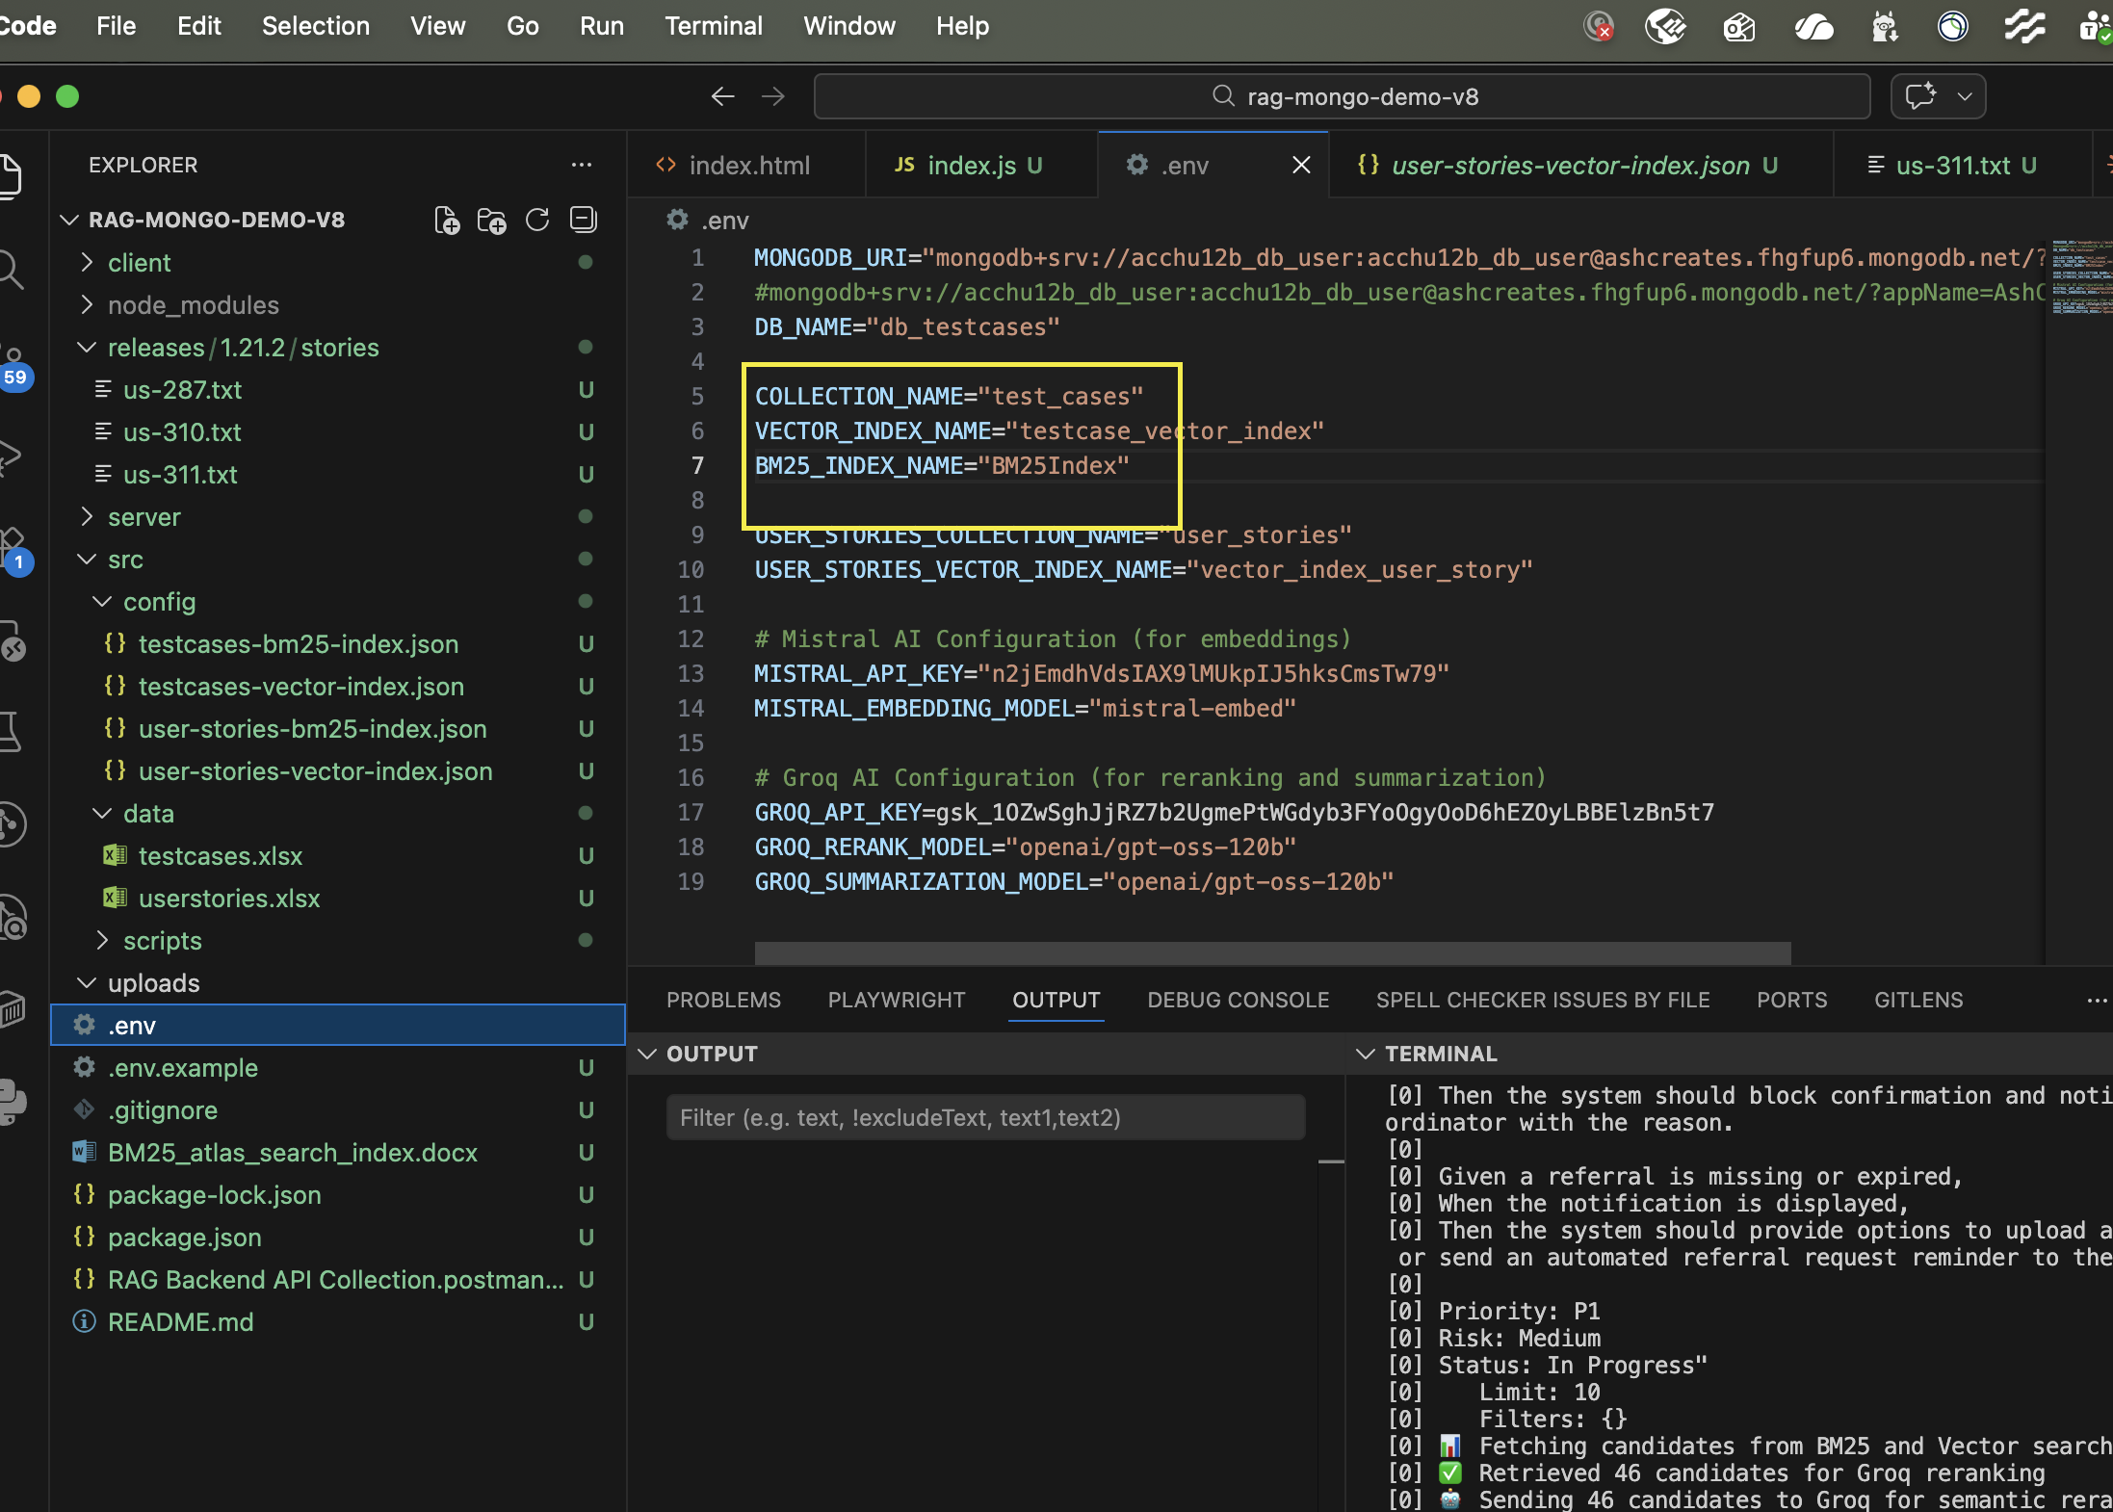
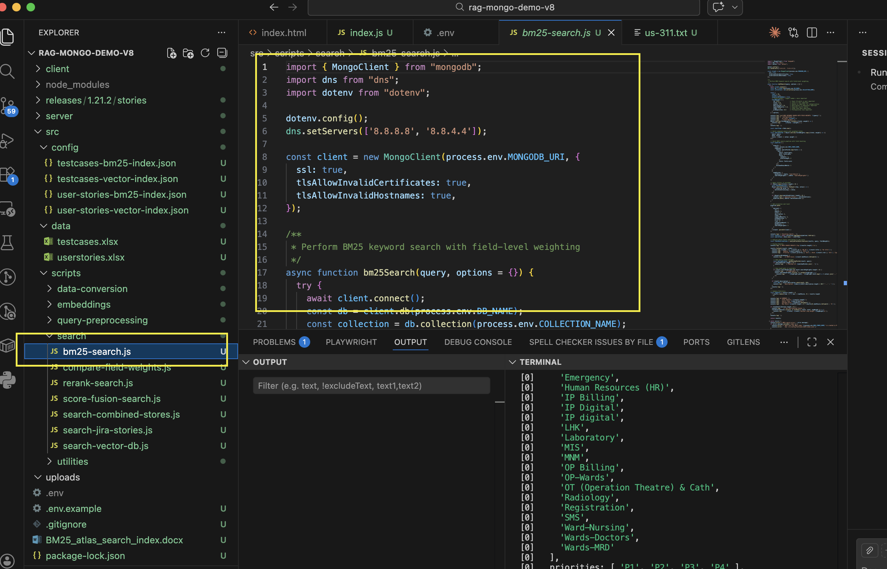

Tried with new USER STORY from Chatgpt added to the comment
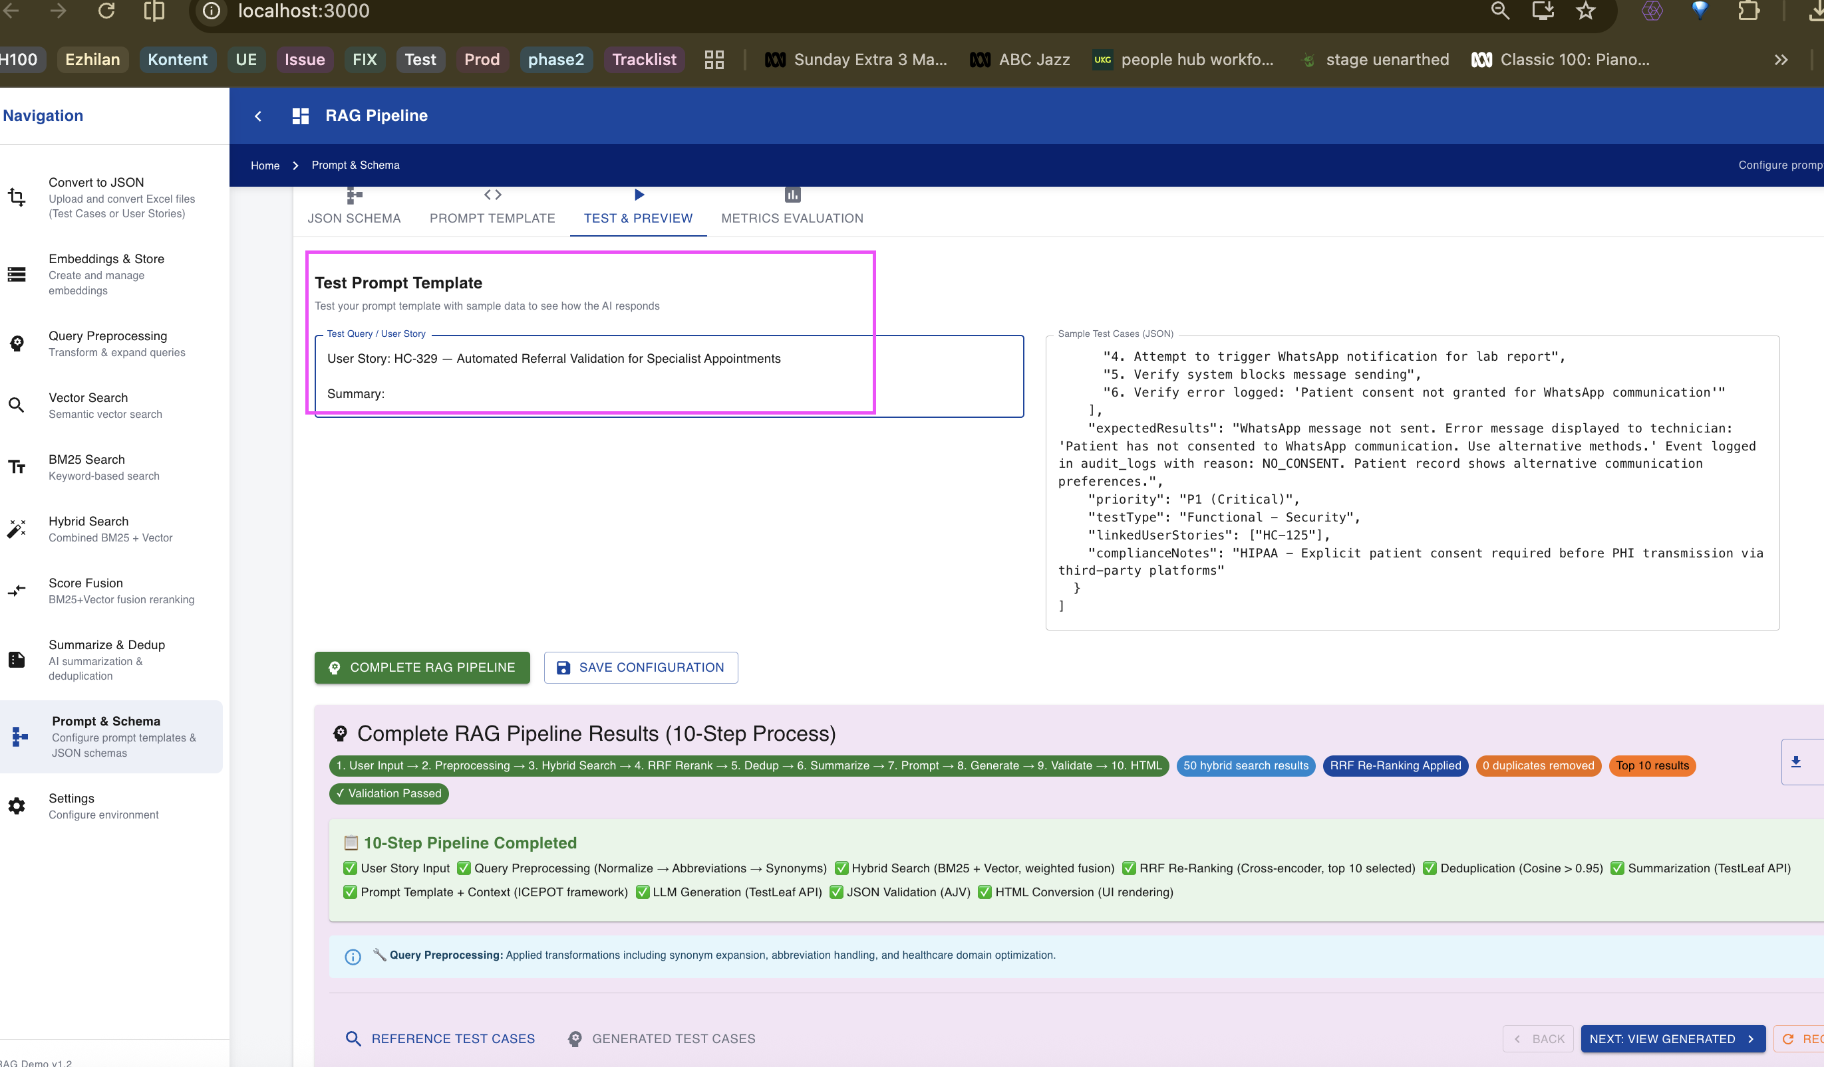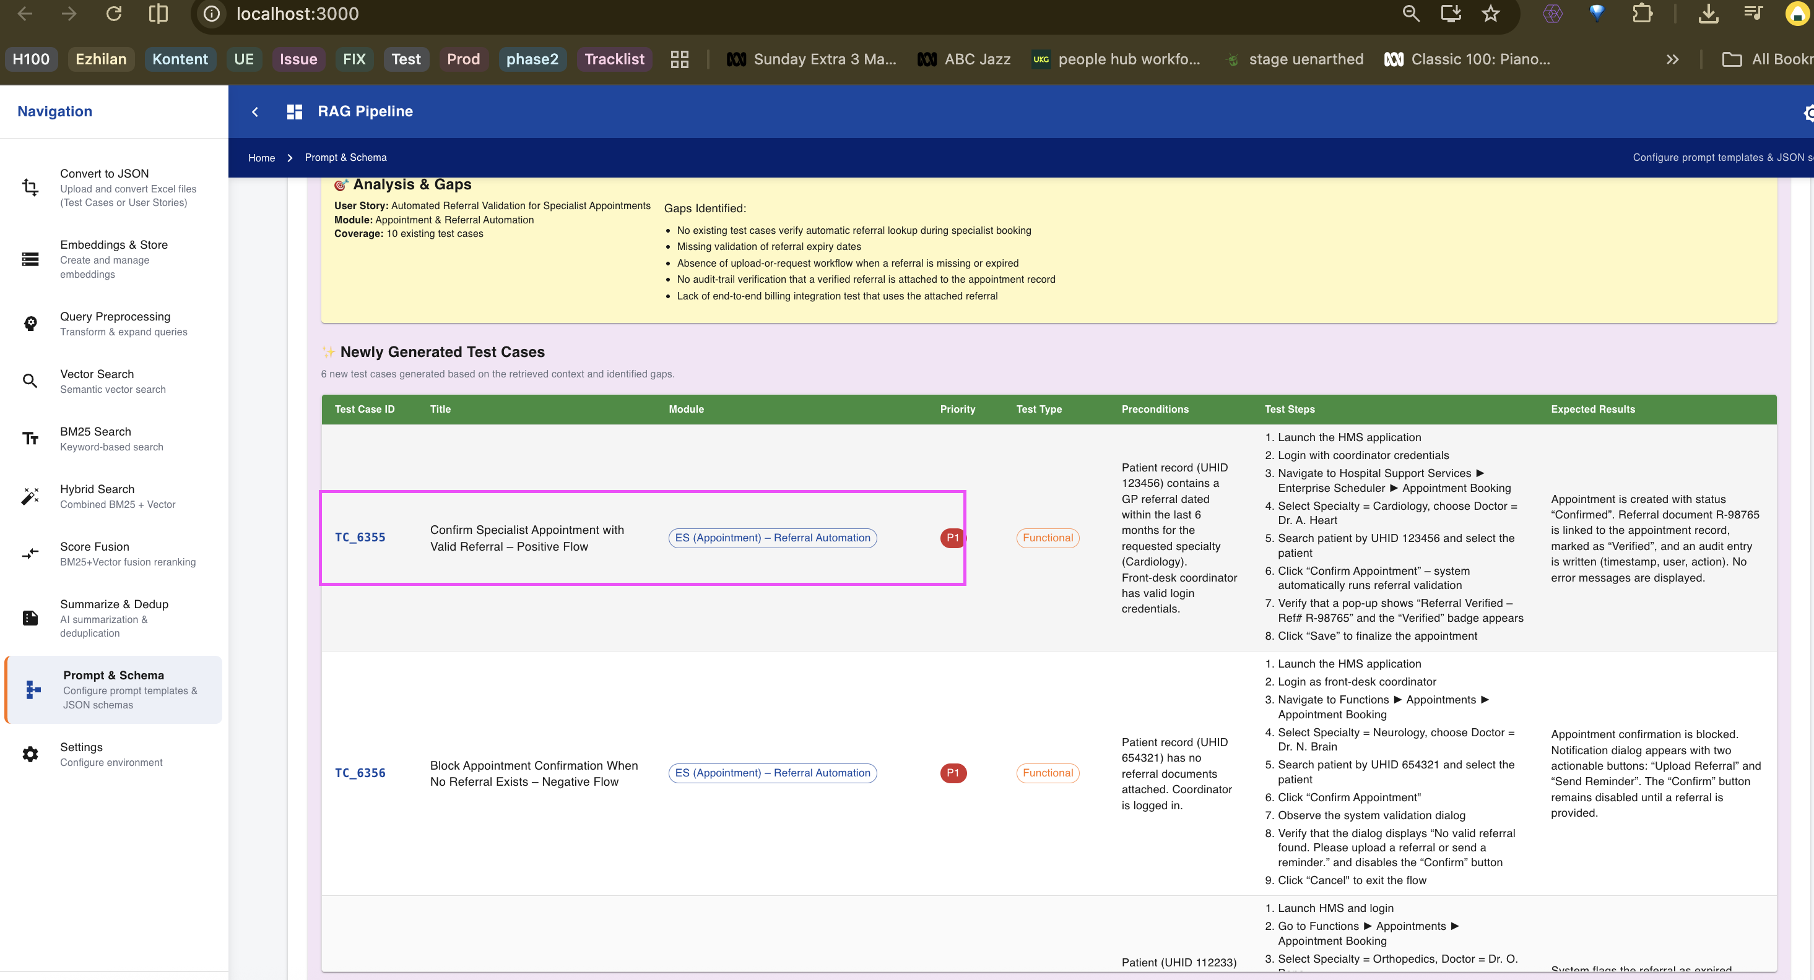

Please complete the above assignment on creating the BM25 search index.

Additionally, explore and test the following functionalities:

* Vector Search
* BM25 Search
* Hybrid Search
* Prompt Schema
* Summarization
* De-duplication

While testing these features, make sure to keep the **Network tab** open and work in debugging mode.

